MAY |  |  | 1)  10:00 Chair Yoga  11:00 Wacky News Wednesday  2:00 Catholic Mass/JH  3:30 Pavilion Stroll |  | 2)  10:15 Kentucky Derby theme Party  2:00 Music/Walker Jacbson  3:30 Left Right Center |  | 3) 10:00 Move & Grove  11:00 Ghost stories  2:00 Cinco de Mayo/  Spanish Dancer/JH  3:30 Sunny stroll  Paranormal day | 4)  10:00 Exercise  11:00 Manicures  1:30 Table Top Games  2:30 Courtyard Walk  KENTUCKY DERBY
5)  10:00 Move to Music  11:00 Manicures  1:30 Sunny Stroll  3:00 Bucket Ball  CINCO DE MAYO | 6)  10:00 Chair Yoga  10:45 Eucharistic Service  2:00 Crafty Corner  3:30 Uno | 7)  10:00 Goodlife Fitness  11:00 Tuesday Trivia  2:00 Music/Bob Devitt  3:30 Table Top Games | 8)  10:00 Stretch & Tone  11:00 Indoor Frisbee  2:00 South Church/JH  3:30 Sunny Stroll |  | 9)  10:00 Music/Rick Daddario, Piano  11:00 Penny for Your Thoughts  2:00 Music/Kathy Gregory  3:30 What to do with lost socks |  | 10)  10:00 Move to Music  11:00 Fun With Words  1:30 OUT TRIP | 11)  10:00 Chair Yoga  11:00 Penny For Your Thoughts  1:30 Bingo  3:30 UNO
12)  10:00 Move to Music  11:00 Manicures  1:30 Bingo/JH  3:00 Table Football  MOTHERS DAY | 13)  10:00 Move & Groove  10:45 Eucharistic Service  2:00 Bingo  3:30 UNO | 14)  10:15 Drum Circle  2:00 Music/Jim Moore  3:30 Sunny Stroll/Frisbee Throw | 15)  10:00 Exercise  11:00 Wacky Wednesday News  2:00 Hungerford Animal Show/JH  3:30 Gardening |  | 16)  10:00 Goodlife Fitness  11:00 Telephone Art  2:00 Music/Mic Iarusso  3:30 Courtyard Walk  Drawing Day |  | 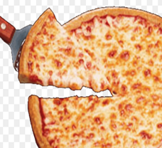  17)  10:00 Chair Yoga  11:00 Fun w ith Words  2:00 African Experience/Games, Pinata  3:30 Our Endangered Species  Pizza Party Day | 18)  10:00 Move & Groove  11:00 Penny Ante game  1:30 Bingo  2:30 Ring Toss  Museum Day
19)  10:00 Stretch & Tone  11:00 Manicures  1:30 Garden Tending  3:00 Sunny Stroll  4:00 Garden Tending | 20)  10:00 Exercise  10:45 Eucharistic Service  2:00 Bingo JH  3:30 Happy Dog Rescue Stories | 21)  10:00 Goodlife Fitness  11:00 Memory Match  2:00 Music/Chip Ames  3:30 Sunny Stroll | 22)  10:00 Move to Music  11:00 Corn Hole  2:30 BLUE/Therapy Dog Visit  3:30 UNO |  | 23)  10:15 Music/Rick Daddario, Piano  11:00 Penny Ante Game  2:00 Music/Doug,accordian guy  3:30 Court Yard Stroll/AR |  | 24)  10:00 Stretch & Tone  11:00 Ping Pong  2:00 Animal Therapy/ Llama Visit  3:30 Tabletop Curling | 25)  10:00 Exercise  11:00 Manicures  1:30 Crafty Corner  3:00 Courtyard Stroll
26)  10:00 Chair Yoga  11:00 Word Chanllenge  1:30 Bingo  3:00 Sunny Stroll/Garden tending | 27)  10:00 Move & Groove  10:45 Eucharistic Service  2:00 Bingo/JH  3:30 UNO  MEMORIAL DAY | 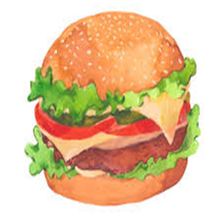  28)  10:00 Goodlife Fitness  11:00 Word Games  2:00 Music/Jeff Wieselberg  3:30 Sunny Stroll/Ball catch | 29)  10:00 Exercise  11:00 Wacky Wednesday News  1:30 OUT TRIP | 30)  10:00 Goodlife Fitness  11:00 Hang Man  2:00 Music/Tony Rarus  3:30 National Creativity Day |  | 31)  10:00 Chair Yoga  11:00 Sunny Stroll/AR  1:30 Garden Maintenance
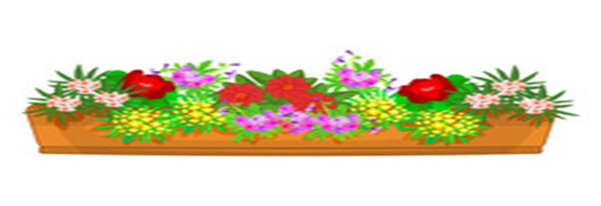
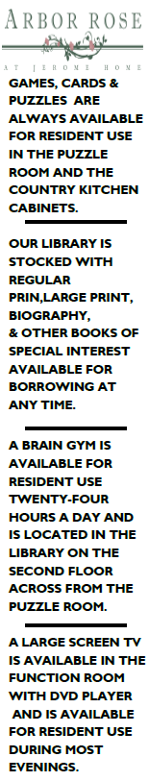
;30

